Home Page
 | Improve Your English Skills  with Myanmar New Era  Learn Listening, Speaking, Reading and Writing with experienced teachers.  International Curriculum  - Small Class Size  - Flexible Schedule  Free Placement Test View Programs
Why Choose Us  Learn Listening, Speaking, Reading and Writing with experienced teachers.   | Expert Teachers  Learn from experienced and qualified English instructors.  4 Skills Focus  Focus on Listening, Speaking, Reading and Writing.  Flexible Schedule  Morning, evening and weekend classes available.  Small Class Size  Small classes for better attention and interaction.
Our Programs
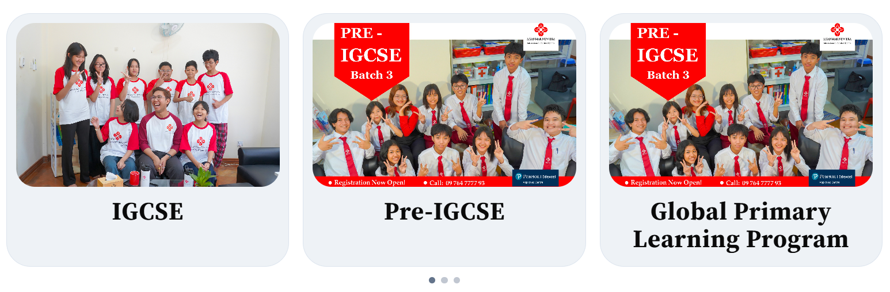
Find Your English Level
Take our FREE placement test and discover the perfect program for you.
60-minute test Instant results
Take Free Placement Test

Our Learning Method  Structured lessons, real communication practice, and materials that support every learner.  Interactive Classes  Students actively participate in discussions and activities.  Real Communication Practice  Practice speaking English in real-life situations.  International Curriculum  Learn with globally recognized learning materials.  Modern Teaching Methods  Modern techniques for effective learning. | 
Meet Our Teachers
Learn from qualified and experienced instructors.

Our Facilities  Modern classrooms, listening labs, and welcoming spaces designed for focused English learning  🏫Modern Classrooms  Well-equipped classrooms designed for comfortable and effective learning.  🔊Listening Labs  Practice listening skills using modern audio equipment and materials.  👥Small Group Classes  Small class sizes allow teachers to give more attention to every student.  ✨Comfortable Learning Environment  A friendly and supportive atmosphere that helps students learn with confidence. | 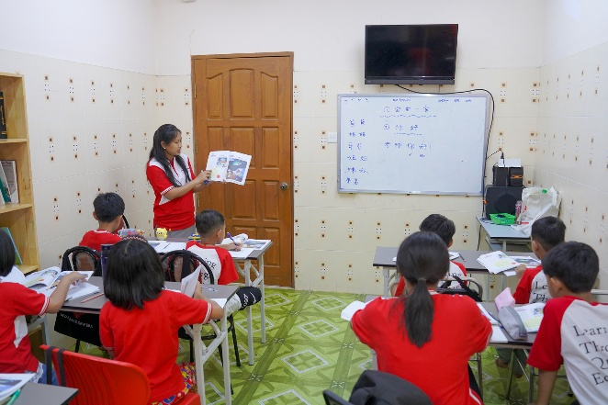
English Levels
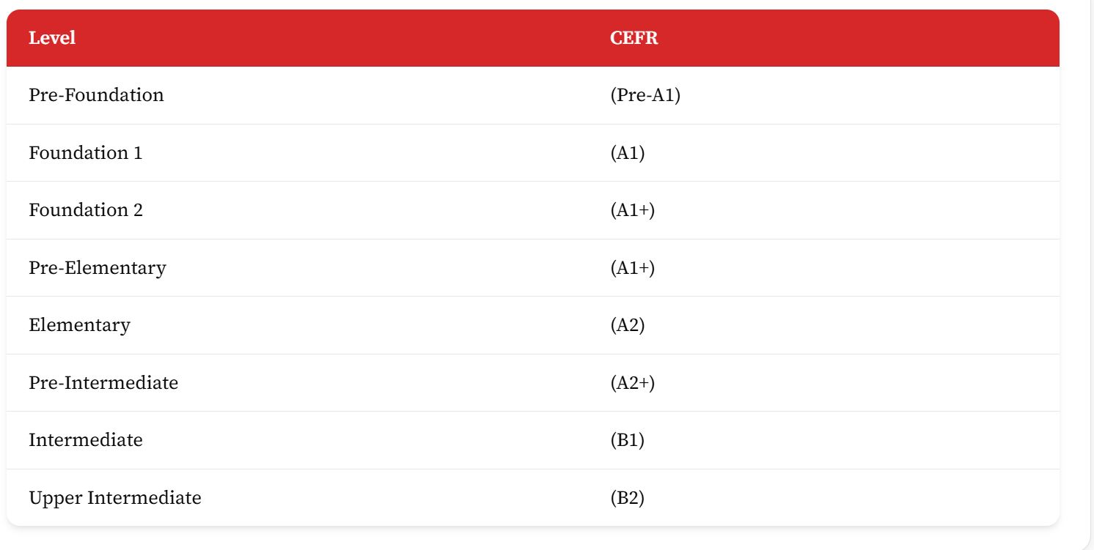
Student's Testimonials
What our students say about learning at Myanmar New Era
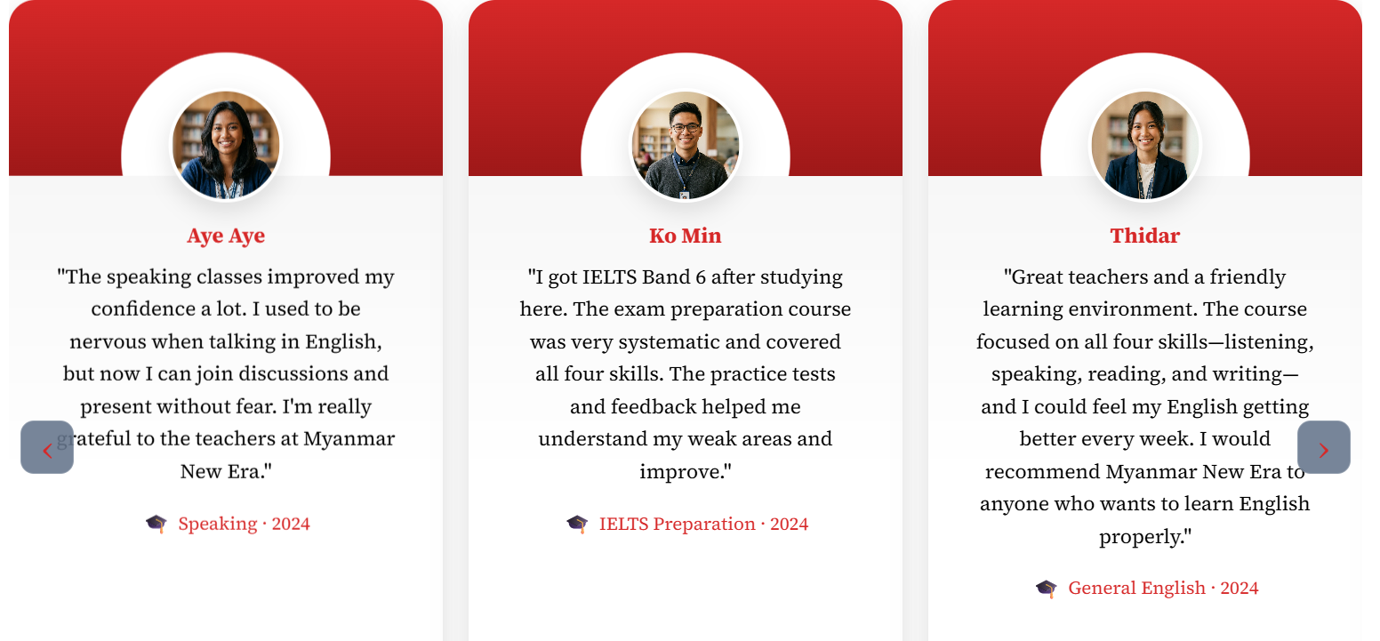
Our Partners


Frequently Asked Questions
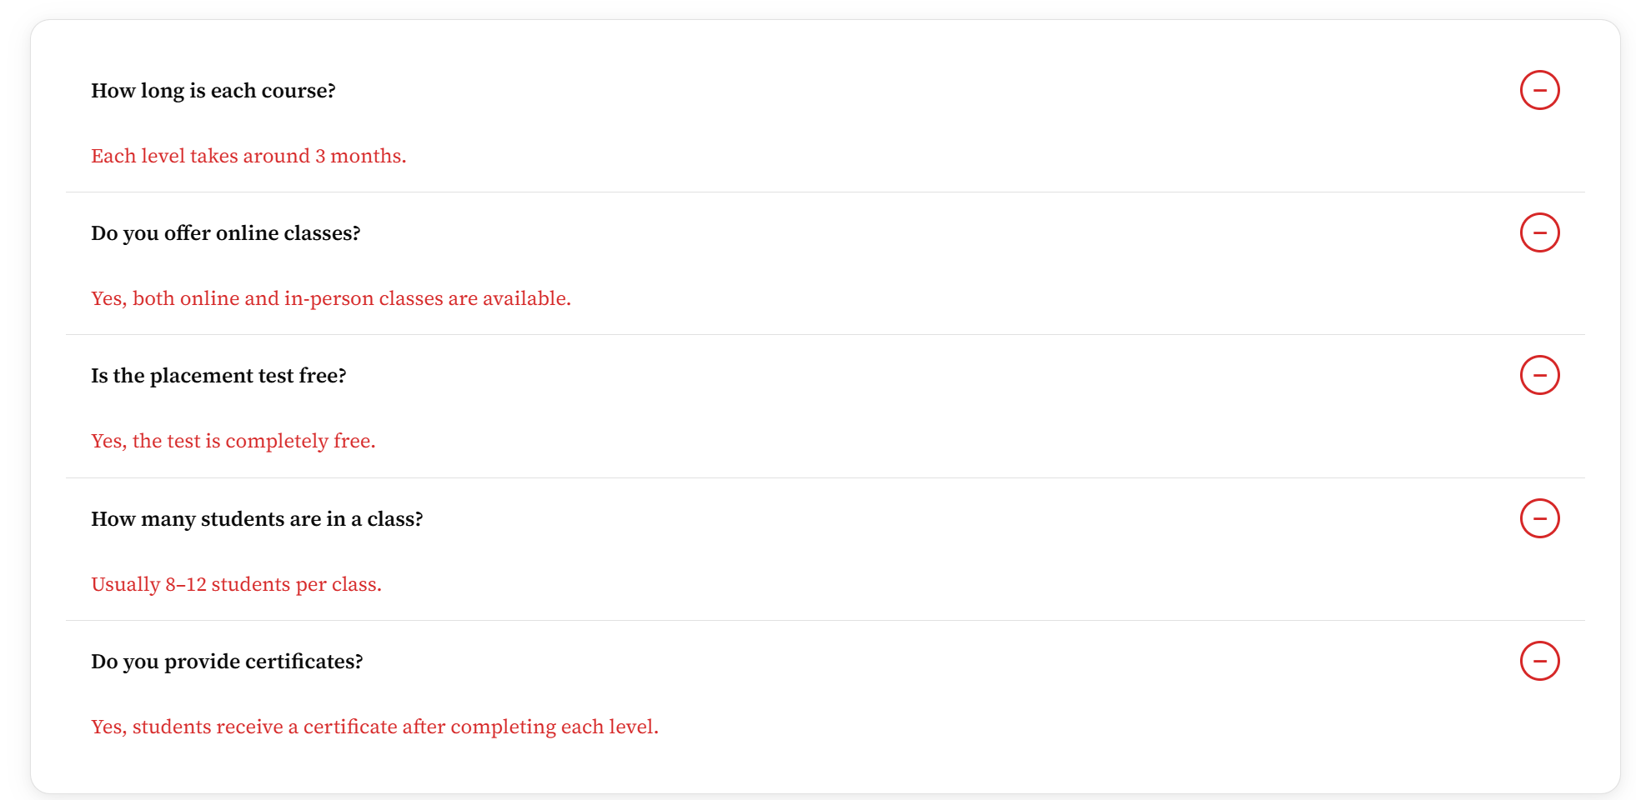
Visit Our Center
No.5311, Myat Lay St & Sagaing St, Ottarathiri 15015, Naypyitaw
📞 +95 9 885 511664, +95 9 885 511665

View Map

